Automate Simple Business Processes with Process Builder

**Learning Objectives**

After completing this unit, you'll be able to:

* List the types of processes that you can build in Process Builder.
* Define the key components used to create a process.
* Build a process that updates the addresses for an account's contacts when the account’s address is updated.

**Get Started with Process Builder**

Process Builder is a point-and-click tool that lets you easily automate if/then business processes and see a graphical representation of your process as you build.

The Components of a Process

Every process consists of a trigger, at least one criteria node, and at least one action. You can configure immediate actions or schedule actions to be executed at a specific time.

Here’s an example of a simple process.

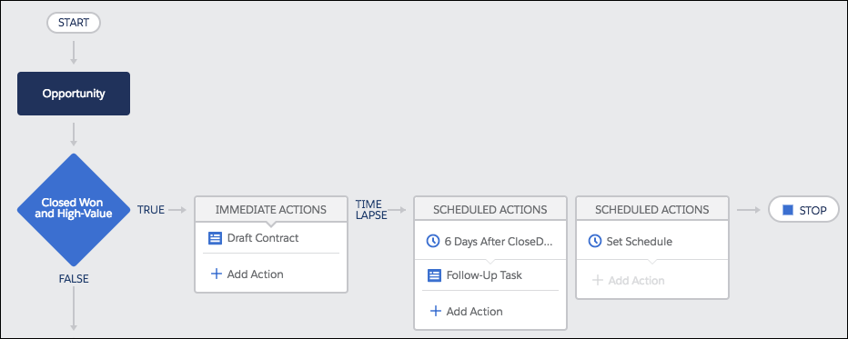

**Trigger: Identify When the Process Should Run**

The trigger identifies when the process should run. For record change processes, the trigger determines which object and which of the following changes the process should pay attention to.

* Only when a record is created
* Anytime a record is created or edited

**Criteria: Determine Whether or Not to Execute Actions**

While a process gets one trigger, you can add as many criteria nodes as your heart desires. Each criteria node controls whether or not the process executes the associated actions. If the record doesn’t meet the criteria, the process skips those actions and moves on to the next criteria node in the process.

In each criteria node, you can:

* Set filter conditions.
* Enter a custom formula. Like in validation rules, the formula must resolve to true or false.
* Opt out of criteria and always execute the associated actions.

**Actions: What the Process Should Do**

When a criteria node evaluates to true, the process executes the associated actions or waits to execute them at a scheduled time.

* Each ***immediate action*** is executed as soon as the criteria evaluates to true.
* Each ***scheduled action*** is executed at the specified time, such as 10 days before the record’s close date or 2 days from now. At the specified time, Salesforce makes sure that the associated criteria node still evaluates to true. If so, the scheduled action is executed. You can schedule actions based on either:
  + A specific date/time field on the record that started the process. For example, a month before an account's service contract expires.
  + The time that the process ran. For example, 3 days from now.

Regardless of when the actions execute, here are some of the things you can do with a process action.

* Create records.
* Update the record that started the process or any related record.
* Submit that record for approval.
* Update one or more related records.
* Send emails using a specified email template.
* Post to a Chatter feed.

If you need more than what’s available in Process Builder, build an autolaunched flow or an Apex class to fill that gap. Then call the flow or Apex from the process.

Process Types

Process Builder can automate a few kinds of business processes. The main difference is the trigger: when the process starts.

| **Type** | **Process Starts When** |
| --- | --- |
| Record Change | A record is created or edited |
| Invocable | It’s called by another process |
| Platform Event | A platform event message is received |

To keep things simple, this unit focuses on the most common process type: Record Change.

Process Builder

Before you dig into the Process Builder, let’s take a quick tour.

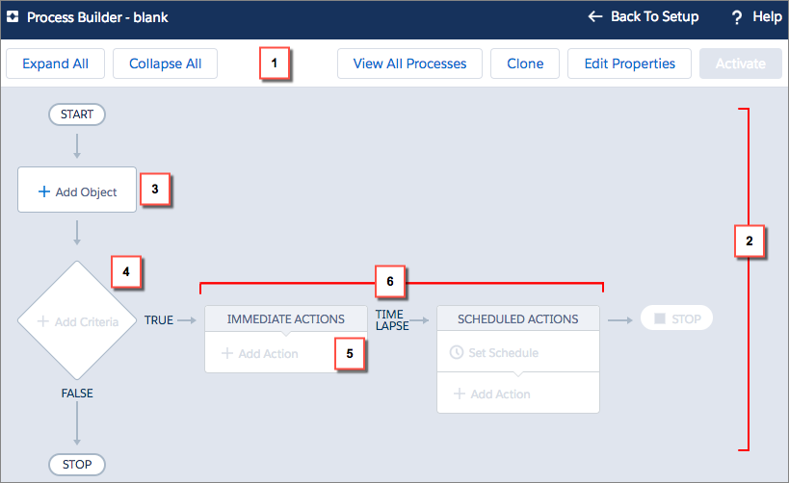

The button bar **(1)** lets you manage the process or view the list of all processes.

The canvas **(2)** is the main workspace for a process. On the canvas, you define:

* The trigger **(3)**
* One or more criteria nodes **(4)**

One or more actions **(5)** in an action group **(6)**

**Build a Process**

Here’s a common use case: If an opportunity is created or updated (*trigger*) and it’s high-value and closed won (*criteria*), then create a draft contract (*immediate action*). Six days after the opportunity closes (*schedule*), create a follow–up task for the account owner (*scheduled action*).

**Tip**

Plan out your business process before you try to automate it. Doing so makes it easier to configure when using one of our automation tools.

1. From Setup, enter Process Builder in the Quick Find box, select **Process Builder**, and then click **New**.
2. Name the process Closed Won Opportunities.

The API name updates to Closed_Won_Opportunities when you tab out of the Name field.

1. For the description, enter If a high-value opportunity is closed and won, create a draft contract and a follow-up task for the account owner.
2. Configure the process to start when a record changes.
3. Click **Save**.

Add a Trigger

1. Click **Add Object**.
2. For Object, enter Opp to filter the list of options and select **Opportunity**.
3. Select **when a record is created or edited**.

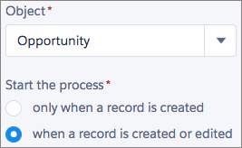

1. Click **Save**.

Add Criteria

Now let’s define the criteria. We check whether the opportunity is closed won and if it’s high-value. In this case, *high-value* means more than $250,000.

1. Click **Add Criteria**.
2. Name the criteria Closed Won and High-Value.
3. Leave **Conditions are met** selected.
4. Check whether the opportunity has been closed and won.
   1. For Field **(1)**, choose **Opportunity** | **Stage**, and click **Choose**.
   2. For Operator **(2)**, leave **Equals** selected.
   3. For Type **(3)**, leave **Picklist** selected.
   4. For Value **(4)**, select **Closed Won**.
5. With another condition, check whether the opportunity is high value.
   1. Click **Add Row**.
   2. For Field **(1)**, choose **Opportunity** | **Amount**, and click **Choose**.
   3. For Operator **(2)**, select **Greater than**.
   4. For Type **(3)**, leave **Currency** selected.
   5. For Value **(4)**, enter 250,000.
   6. Be sure **All** conditions are met is selected.

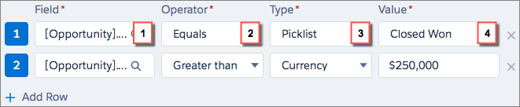

1. Click **Advanced** and select **Yes**.

When you select this option, the process ignores record changes that aren’t relevant to your defined criteria. For example, if the opportunity’s description is updated, the process won’t execute the associated actions.

1. Click **Save**.

Add a Schedule

Let’s have the owner follow up with the account 6 days after the opportunity closes.

1. Under Scheduled Actions, click **Set Schedule**.
2. Set the schedule for 6 days after the opportunity closes.

Set a Schedule panel

1. Click **Save**.

Add Actions

Now let’s define the actions that execute when the criteria are met. We need an immediate action that creates a draft contract and a scheduled action that creates a task for the account’s owner.

**Immediate Action**

1. Under Immediate Actions, click **Add Action**.
2. For the action type, select **Create a Record**.
3. Name the action Create Draft Contract.
4. For Record Type, select **Contract**.

When you select the object that you want to create a record for, Process Builder displays rows for the required fields.

1. To associate the contract with the opportunity’s account, set Account ID.
   1. For Type, select **Field Reference**.
   2. For Value, select **Opportunity** | **Account ID** and then click **Choose**.

**Tip**

When you select a value without Traverser icon next to it, you're selecting a field. To use fields on related records, click a value with Traverser icon next to it.

1. Make sure that the new contract is a draft. In the Value for Status, select **Draft** from the dropdown list.

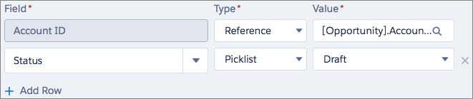

1. Click **Save**.

**Scheduled****Action**

1. Under the schedule we created earlier (6 Days After Close Date), click **Add Action**.
2. For Action Type, select **Create a Record**.
3. Name it Follow-up Task.
4. For Record Type, select **Task**.
5. Set the task's field values.

| **Field** | **Type** | **Value** |
| --- | --- | --- |
| Assigned to ID | Field Reference | Opportunity > Account ID > Owner ID |
| Priority | Picklist | High |
| Status | Picklist | Not Started |

1. Click **Save**.

Success! You’ve created a process that automatically manages your high-value business opportunities.



To start using this process, just activate it.

V

## ****What is process builder in Salesforce?****

[Salesforce](https://www.janbasktraining.com/blog/what-is-salesforce/) process builder is a powerful tool you can use to automate business processes. It has a simple interface that allows you to point and click to select objects and fields while setting up immediate and time-based actions. Process builder allows you to do more than a simple workflow would. It is a tool that allows you to automate business processes using a graphical representation of your process. It is like workflow tool that helps you easily automate your business processes by providing a powerful and user-friendly visual representation of your process. The Process Builder’s simple and powerful design allows you to build customize the automated process.

### Actions Available In Process Builder

There are several different actions you can [trigger](https://www.janbasktraining.com/blog/what-is-trigger-in-salesforce/) the process builder. These actions are: **Trigger Apex code:**You can use Salesforce process builder to invoke Apex code you have written within Salesforce. Apex can be anything from custom logic to save a record to complex business processes. To invoke an apex class in process builder we have to use **@AuraEnabled** attribute. **Create a record:**This will allow you to create new records and set certain field values for the new record. **Email alerts:**IN order to send an email from a process, you must create the email alert. To send an email alert that email should be associated with the same object on which process is started. Email template contains the standard text, list of recipients, and template **Trigger a flow:**You can launch a flow from your process to automate complex business processes. **Post to Chatter:**Process builder post to chatter action helps to post information to any user or group chatter feed within Salesforce. The post will appear in the chatter field as if the person who triggered the process had written it. You can reference groups or topics and add merge fields. **Submit for approval:**Only the record that started the process will be submitted. You can’t submit any related records for approval. **Update records:**Update one or more records that are related to the record that started the process. You can update the record with manually entered values or by using the values from related records. We can update records of parent or child whereas workflow only updates same or parent object from the child. **Quick actions:**You must already have global actions or an object specific action created within Salesforce to use these quick actions. You can then select to log a call, send an email, or update a record. **Process:**This action will call another process to another process. For this action, you need to choose process type as it invoked by another process.

### ****Why Process builder?****

Process builder is more flexible in comparison to workflow.In workflow rule can’t update child record, Post to Chatter, auto submits record in the [Approval process](https://www.janbasktraining.com/blog/how-to-create-your-first-approval-process-in-salesforce/), invoke an apex or call flows.

Say Goodbye to Workflow and Hello to Process Builder

**Learning Objectives**

After completing this unit, you’ll be able to:

* Explain the business value of Process Builder compared to Workflow.
* Describe the overall process of converting workflow rules to processes.

**New Company, New Org**

You’ve been working at Acme Wireless for a few months now. As you familiarize yourself with the inner workings of your new org, you keep mental notes of areas for improvement. Some of those areas you can address with quick fixes.

Others are implementations of solutions that aren’t necessarily the best practice for that problem. But the implementations work so there’s no burning need to fix them. It’s hard enough to keep apprised of newfangled features (hello, 1,200 pages of release notes every year), much less to actually *implement* those features. You don’t always have the time. Or even if you do have the time, the benefits aren’t enough to warrant it.

One such area for improvement: the large number of workflow rules used to automate everything rather than Process Builder.

**Important**

The examples described in this module include custom fields and email templates that don't exist in your Trailhead Playground. This module doesn't show you how to create those fields or templates, because our focus is on the concepts and best practices for migrating workflow rules. We recommend that you read along to understand the concepts, but don't try to follow the exercise steps in your playground. You apply your conceptual knowledge to complete the challenges at the end of each unit. Don't worry: you don't need to create any custom fields or email templates to complete any of the challenges.

**Let’s Compare: Workflow vs. Process Builder**

What’s the big deal? #AwesomeAdmin, why spend your time converting automation from a tool that you know to a tool that you don’t know?

**Process Builder lets you automate more things.**

Process Builder includes more flexible actions compared with the corresponding workflow actions. The Create a Record process action, for example, lets you create any record instead of just tasks. Also, the Update Records process action (which corresponds with the field update workflow action) lets you update any related record, while the field update workflow action lets you update only the record or its parent.

Process Builder also includes brand new actions that aren’t available in Workflow—such as Post to Chatter and Submit for Approval.

**Process Builder lets you control the order of your criteria.**

In Workflow, there’s no way for you to determine which order your workflow rules run in. So there’s always a risk of one rule overwriting what another did. In Process Builder, you determine the exact evaluation order of your process’ criteria. In turn, within a given process criteria, you determine the order of its actions.

**Tip**

Because you can’t choose which workflow rule is evaluated first, choose one tool to automate everything for a given object. If you use both Workflow and Process Builder, you can’t reliably predict the results of a record change.

**Process Builder lets you access fields on every related record.**

In Workflow, you can reference fields on the record’s parent. Process Builder, on the other hand, lets you access the fields on any related record, no matter how far away that record is. You can reference fields on a parent record, grandparent record, or great-great-great-grandparent record twice removed.

**Process Builder is the future.**

We’re no longer enhancing Workflow. We still support your use of workflow rules, and will continue to do so. But all new functionality for the workflow use case will come through Process Builder. If you want to use the shiny new functionality, migrate your automation to Process Builder.

Now you have all the information you need to decide between Workflow and Process Builder for future projects.

**New Business Requirements**

Change is a constant, in life and in your work as a Salesforce admin. So you’re not that surprised when you receive this email from the VP of customer service.

A few months ago, we (or rather, your predecessor) rolled Chatter out to the company. As the executive sponsor, I’m jazzed to see adoption rising! But we’ve got some ways to go before we hit our target metrics. My team identified a possible way to push the needle even further, so I have a simple request.

The support team receives tons of emails about their cases from Salesforce automatically. Can you change the implementation so that the team is notified via Chatter instead of email?

First, take a moment to chuckle. There’s no such thing as a simple request.

But nonetheless, it’s time to investigate the best way to change your org’s case management system. Three items in your admin toolkit let you automatically create Chatter posts: Apex triggers, Flow Builder, and Process Builder. Of those tools, Process Builder is the simplest. So you plan to migrate the Case-based workflow rules that send emails into processes with Process Builder.

Let’s take a second to review the existing Case workflow rules.

| **Rule Name** | **Criteria** | **Actions** |
| --- | --- | --- |
| Escalate Based on Keywords in Subject or Description | Evaluation Criteria: created or edited to subsequently meet criteria  Rule Criteria:  **Contains**(**LOWER**( Subject ),**"urgent"**) ||  **Contains**(**LOWER**( Subject ),**"password"**) ||  **Contains**(**LOWER**( Subject ),**"down"**) ||  **Contains**(**LOWER**( Subject ),**"emergency"**) ||  **Contains**(**LOWER**( Subject ),**"internal server error"**) ||  **Contains**(**LOWER**( Description ),**"urgent"**) ||  **Contains**(**LOWER**( Description ),**"password"**) ||  **Contains**(**LOWER**( Description ),**"down"**) ||  **Contains**(**LOWER**( Description ),**"emergency"**) ||  **Contains**(**LOWER**( Description ),**"internal server error"**)  Copy | Immediate:   * Field Update: Set Priority to Service Affecting * Field Update: Set Support Level to Tier 3 * Field Update: Set Target Resolution Date to TODAY()   Time-Dependent: n/a |
| Follow Up When a Platinum Contract Case Closes | Evaluation Criteria: created or edited to subsequently meet criteria  Rule Criteria:   * (Case: Priority equals High) and * (Case: Closed equals True) and * (Case: Contract Type equals Platinum) | Immediate: n/a  7 Days After Case: Date/Time Closed:   * Email Alert: Email a feedback request to the case contact |
| Notify Sales VP About Cases Filed for High-Value Accounts | Evaluation Criteria: created  Rule Criteria: (Account: Top Account equals true) | Immediate:   * Email Alert: Notify AE about cases for large accounts * Email Alert: Notify AE’s manager about cases for large accounts   Time-Dependent: n/a |
| Set Resolution Date for Basic Support | Evaluation Criteria: created  Rule Criteria: (Case: Support Plan equals Basic) | Immediate:   * Field Update: Set the Target Resolution Date to TODAY() + 30   Time-Dependent: n/a |
| Set Resolution Date for Premium Support | Evaluation Criteria: created  Rule Criteria: (Case: Support Plan equals Premium) | Immediate:   * Field Update: Set the Target Resolution Date to TODAY()   Time-Dependent: n/a |
| Set Resolution Date for Standard Support | Evaluation Criteria: created  Rule Criteria: (Case: Support Plan equals Standard) | Immediate:   * Field Update: Set the Target Resolution Date to TODAY() + 14   Time-Dependent: n/a |

Only two of the five workflow rules include email alert actions. However, it’s best practice to avoid mixing processes (from Process Builder) with workflow rules for a given object. Otherwise, you can’t guarantee what order the processes and workflow rules are evaluated in. If you want to replace one case workflow rule with a process, we recommend migrating every case workflow rule to Process Builder.

**Convert Your Workflow Rules into a Process**

The cost of new features is exacerbated when those features don’t have automatic migration options. We know: the idea of clicking a button to convert your workflow rules to Process Builder sounds super awesome. Unfortunately, workflow rules are different enough from processes to make that impossible. So we’re going to give you the next best thing: a module to walk you through the migration process.

It’s a bit meta, but this is the process to move away from Workflow and toward Process Builder. We cover each of these steps throughout this module.

**Tip**

Build and test your processes in a sandbox environment. That way, you can identify any issues without affecting your production data.

1. Map your rules’ criteria into process criteria. Consider whether to nest any criteria with invocable processes.
2. Map your rules’ actions into process actions.
3. Determine the optimal order of your criteria nodes.

We take each step in three parts: discussing what to consider during that step, drafting a plan for that step, and then implementing that plan in Process Builder. Throughout this module, we use tables to represent the plan. But you can use whatever planning tool you prefer. Pen and paper is just as good as a whiteboard or spreadsheet.